120 Aviation Way, Watsonville, CA 95076
Tel: (831) 722-4155 E-Mail: info@united-flight.com

Registration: N396TA (Updated 3/10/2026)
Year/Make/Model:
2003 Cessna 172SP, 180HP, Fuel Injected

Speed:
Maximum at Sea Level…………………….……………. 126 KTS
Cruise, 75% Power at 8500 FT……………….…….... 124 KTS

Rate of Climb at Sea Level……………….….…….…. 730 FPM
Service Ceiling……………………………………….….… 14,000 FT

Fuel Capacity ……………………………………………..… 56 GAL
Oil Capacity ……………………………………………………. 8 QTS

Take of Performance:
Gound Roll………………………………………………..…….. 960 FT
Total Distance Over 50 Ft Obstacle………………… 1630 FT

Landing Performance:
Ground Roll……………………………………………….…….. 575 FT
Total Distance Over 50 Ft Obstacle…………….…… 1335 FT

Maximum Weight:
Ramp …………………………………………………….…….. 2558 LBS
Takeoff…………………………………………………………. 2550 LBS
Landing ………………………………………………………… 2550 LBS

***SEE WEIGHT AND BALANCE RECORDS FOR CURRENT DATA***
Notice to Pilots: The data provided on this sheet is for reference only and is NOT TO BE USED AS YOUR SOLE SOURCE OF DATA. As with all aspects of flight planning and aircraft operation, it is your responsibility to confirm that the data used is current and accurate before each flight.

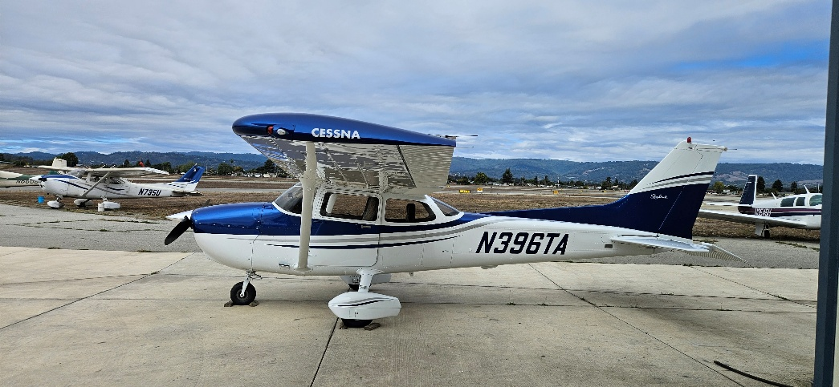
Aircraft Exterior

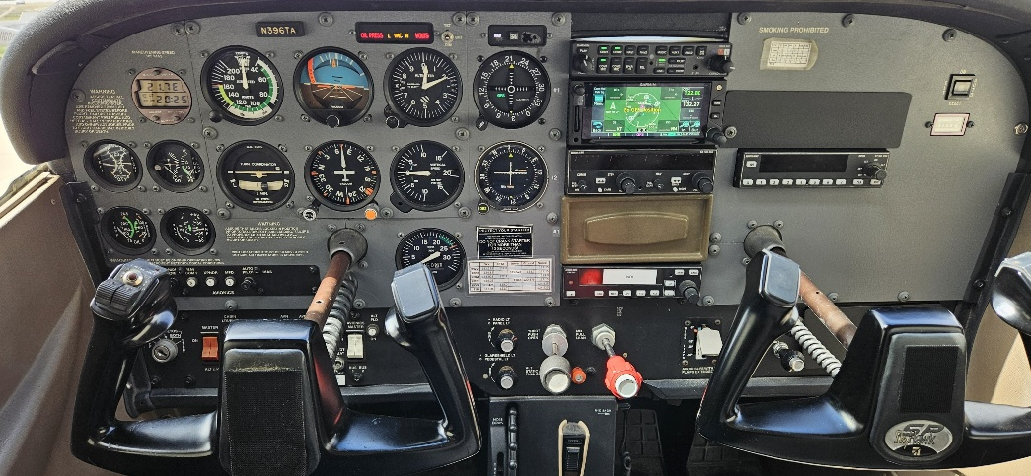
Panel

